Improving the identifiability of hydrological model parameters through remotely sensed data and sequential calibration

Jesús Casado-Rodríguez(1,2), Manuel del Jesus(3) and Salvador Navas(4)

(1,3,4) IHCantabria - Instituto de Hidráulica Ambiental de la Universidad de Cantabria, Santander, Spain.   
manuel.deljesus@unican.es; salvador.navas@unican.es

(2) Tecnologías y Servicios Agrarios S.A., Oviedo, Spain,  
jcasado4@tragsa.es

Abstract

Conceptual hydrologic models suffer from parameter identifiability problems, that is, many different sets of parameters provide equally good-performing calibration and validation statistics. It means that, as far as we can measure, all those parameter sets capture equally well the observed data. This plethora of sets indicates that the model may not be properly capturing the processes at work. Among other reasons, this behaviour is due to the reduced number of variables used in the calibration process. Remote sensing information provides spatially distributed information that may complement the typical calibration variables, helping to reduce the parameter identifiability problem. In this study, remote sensed data providing information about the spatial distribution of snow and evapotranspiration are used to reduce the set of “optimal” parameters. Moreover, calibration is carried out decomposing the measured river discharge signal with a disaggregation method that further improves the calibration and validation results.

**Keywords:**Equifinality; Remote sensing; Snow; Evapotranspiration; Calibration

1. INTRODUCTION

Current hydrological models tend to use a large number of parameters to represent the different processes in the water cycle. Physically based models may have a clear identification of these parameters with physical processes, but conceptual models show a weak link between parameters and processes. The larger the flexibility required from the model -due to the complexity of the processes to be captured-, the larger the number of parameters needed, and hence, the larger the problem of parameter identifiability.

The calibration of conceptual models serves to adapt the model parameters so that the model reproduces the observed physical processes. The calibrating process is, however, an aggregation of effects, where the effect of each individual parameter cannot be easily identified. Therefore, the more complicated the problem to be solved, the more complex the model required and the more difficult becomes to properly calibrate the model. An inherent component of this difficulty is equifinality, i.e., the property of a hydrological model to reproduce equally well the observations with different sets of parameters, that in turn imply different relative contribution of the processes considered in the model (Beven, 2001). Equifinality limits the usefulness of the calibrated model since there is no warranty that the model will properly reproduce processes for which it has not been explicitly calibrated. Indeed, this difficulty is specially limiting to evaluate the impacts of climate change, for instance.

Equifinality may be reduced if calibration includes different variables (Beven, 1992) and not only river discharge, which tends to be the standard calibration technique. Under this perspective, remote sensing provides a valuable source of information, since it does not only provide information about several hydrological variables (snow cover, evapotranspiration, etc.), but it also provides the spatial distribution of this information. The spatial nature of remote sensing data implies that calibration may be carried out at several points, increasing the total amount of information that the model parameters account for. Examples of calibration of hydrological models that use remote sensing information can be found in recent literature (Koch, 2018; Pasquato, 2015; Ruiz Pérez, 2016; Wambura, 2018).

The main limitation of remote sensing is that it can only provide information about surface processes, or at least about very shallow processes, so it may not help in the identification of parameters for subsurface processes, such as the partition between baseflow, surface runoff and interflow. To deal with this uncertainty in the absence of additional information, hydrograph separation techniques are used to disaggregate the river discharge signal (Casado-Rodríguez, 2019).

In the present paper, we show how the combination of hydrograph disaggregation and remote sensing may help to identify the parameters of a conceptual hydrological model.

1. METHODS

In this study, the TETIS (GIMHA, 2018) hydrological model will be used. TETIS is a conceptual, distributed hydrological model that represents the water balance with a series of interconnected deposits, each deposit representing a storage in the water cycle. Specifically, TETIS uses seven deposits: four soil layers, a deposit for interception, another for the snowpack, and a last one that represents the stream routing.

* 1. **Study area**

The study area comprises the Deva River basin (291 km2), a mountainous catchment in the Picos de Europa National Park (Northern Spain). The watershed presents characteristics of both middle and high mountain catchments. The elevation ranges from sea level to 2.614 m with an average altitude of 1.167 m. The Deva River basin presents a small level of human intervention, although it cannot be considered a purely natural and undisturbed river basin.

Elevation characteristics are obtained from topographic national maps. Official databases are also used to extract information about soil properties and land cover. The watershed is covered with forest in 44% of its area, and shrublands in 35%. Climatological information is obtained from AEMET rain gauges and thermometers close to the Deva River basin. The average rainfall over the watershed is 1.650 mm per year, while the average temperature is 11º C.

In addition to the usual information required to prepare and calibrate the hydrological model (river discharge in all the measurement stations in the watershed), additional remote sensing information was used. Specifically, times series of snow cover and evapotranspiration maps were derived from satellite images of the MODIS mission. These images were processed to obtain snow cover and evapotranspiration maps, that can be used to compare with the snow cover and evapotranspiration maps produced by the TETIS hydrological model and that inform the parameter calibration procedure.

* 1. **Model calibration**

The calibration procedure followed in this study proceeds from the surface processes -snow cover and evapotranspiration- to the deep ones -runoff generation in the different soil layers-. Under this scheme, snow accumulation and fusion are calibrated first. In this case, the results from the TETIS model are compared against the snow cover maps derived from MODIS images. The calibration function used is the SPAEF (Koch, 2018). SPAEF is a metric that measures the efficiency of a model in spatially extensive variables that follows a logic similar to the one developed for the Kling-Gupta Efficiency (KGE) (Gupta, Kling, Yilmaz, & Martinez, 2009) that is often used with time series. After the snow cover calibration, the same procedure is used to calibrate evapotranspiration. These two first steps serve to calibrate the model parameters that represent rainfall interception, snowpack behavior and the static water storage. The inclusion of this information serves to reduce the bias of the model.

The calibration of the remaining deposits, the three soil tanks and the streams, is carried out with a disaggregation scheme of the discharge time series. In this case, the observed discharge time series are decomposed into quick and slow flow. We assume that the sum of the surface runoff and the interflow is equal to the quick flow determine by hydrograph separation. Thus, the surface tank and the gravitational tank are calibrated against the quick flow time series, with the previously calibrated tanks using their already determined parameter values. Once this calibration is finished, the slow flow component, the baseflow, is used to calibrate the aquifer tank, corresponding to the groundwater flow. The total discharge is used to calibrate routing, that is, the overall behavior of stream flow in the stream tanks. In all the previously referenced cases, where discharge of one type of another is considered, the optimization function considered for calibration is the well-known Nash-Sutcliffe Efficiency (NSE) (Nash & Sutcliffe, 1970).

As a benchmark to compare against the decomposition procedure, the catchment also undergoes a standard calibration, i.e., all parameters are calibrated against total discharge.

1. RESULTS
   1. **Snow cover maps**

The snow cover maps used for calibration are generated combining two different MODIS products: MOD10A2 (Terra) and MYD10A2 (Aqua). Those maps date back to 2001 and a temporal resolution of 8 days, and a spatial resolution of 500 m. The raw data is processed and combined to generate binary maps of presence and absence of snow as shown in Figure 1, where the maps for a specific date are shown. Similarly, the outputs from the hydrological model, maps of snow water equivalent (SWE), are converted into binary maps.

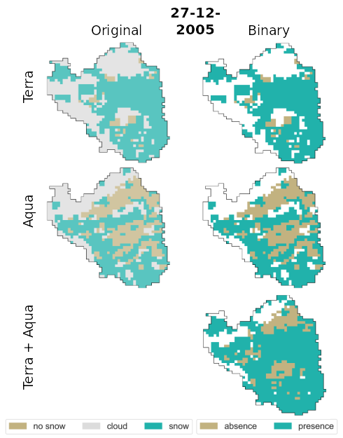**Figure 1**. Example of snow presence and absence maps generated from the MODIS satellite images.

Since both snow observation and simulation data is converted to maps presence or absence of snow, the calibration process becomes a binary classification problem. The objective function used to optimize de three parameters involved in TETIS’ snow processes is the f1-score, a typical scoring in binary classification. The optimization algorithm used during calibration is Shuffled Complex Evolution University of Arizona (SCEUA) (Duan, Sorooshian, & Gupta, 1992).

Figure 2 shows the results from the calibration of snow processes. The two panels at the top show the state variable and fluxes related to snow in the hydrological model, i.e., the snow water equivalent (SWE) and the snowmelt (SM). The two panels at the bottom show the calibration performance regarding the number of cells in the catchment covered by snow (either observed of simulated) and the associated f1-score.

**Figure 2**. Validation of the snow cover results generated by TETIS.

* 1. **Evapotranspiration results**

The calibration of evapotranspiration uses several satellite products. MODIS supplies two evapotranspiration (ET) products: MOD16A2 (Terra) and MYD16A2 (Aqua). Similar to the snow products, this data dates back to 2001 and has 8 day and 500 m temporal and spatial resolution, respectively. This ET product is a derivation of other MODIS products. On the one hand, the MODIS land cover product MCD12Q1 is a yearly map of land cover classes with the same observation period (since 2001) and resolution (500 m) as the rest of MODIS products. On the other hand, the MODIS leaf area index (LAI) product MCD15A2H.

We crossed MODIS LAI and land cover data to derive the monthly series of maximum interception for each land cover class, a piece of information that TETIS requires to compute interception. Furthermore, TETIS requires monthly crop coefficients to convert potential evapotranspiration to actual evapotranspiration; we estimated this crop coefficients from both MODIS ET and land cover data. Finally, the calibration of evapotranspiration applies to three model parameters that control not only the evapotranspiration flux, but also infiltration and field capacity. To fit these parameters, we compared the monthly observed and simulated ET, using SCEUA as optimization algorithm and the Nash-Sutcliffe efficiency coefficient (NSE) as the objective function.

The evapotranspiration results shown in Figure 3 manifest the good reproduction obtained for this variable due to the calibration procedure. The figure shows the potential evapotranspiration estimated from meteorological records via the Hargreaves method (Hargreaves & Samani, 1985), the observed MODIS evapotranspiration and the actual evapotranspiration simulated with TETIS.

The results prove that the model is still very sensitive to the information provided as potential evapotranspiration. The signal modulation correctly captures the observed evapotranspiration signal, but the amplitude of the modeled signal is strongly controlled by potential evapotranspiration. Different schemes to account for evapotranspiration should be analyzed to determine whether this dependency is related to the evapotranspiration model or if it has its roots in some of the soil layers.

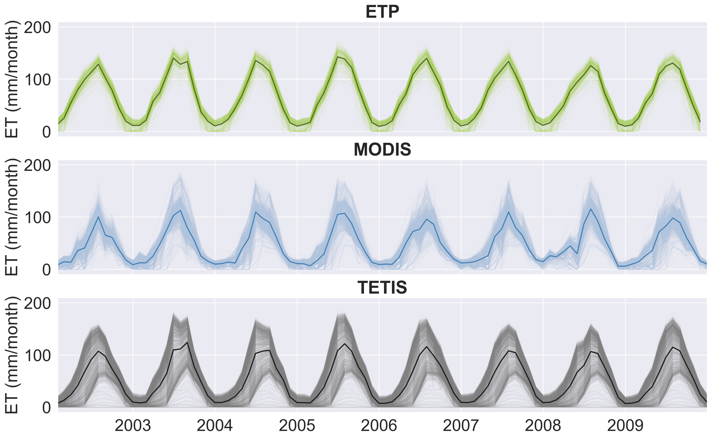**Figure 3**. Monthly series of evapotranspiration. At the top, potential evapotranspiration (ETP) estimated from meteorological records; in the center, MODIS observed evapotranspiration; at the bottom, the actual evapotranspiration simulated with TETIS. The ETP signal has an important impact, but the calibration against MODIS information provides an adequate modulation of evapotranspiration.

1. CONCLUSIONS

We have presented a method to calibrate stepwise the snow and vegetation processes in a conceptual hydrological model using satellite products as the source of observed information. On the one hand, we used satellite snow products converted to binary maps to fit the snow accumulating and melting processes. On the other hand, we used satellite vegetation products (ET, LAI and land cover) to estimate vegetation properties and to calibrate the model parameters that involve evapotranspiration. The total equifinality, i.e., the spread of model parameters with equivalent performances, is reduced, although this reduction does not fully remove the identifiability problem.

Further experimentation is required to improve the performance of the calibration schemes. Future developments of this research should include the calibration of snow water equivalent instead of snow presence, or using a spatial objective function in the calibration of evapotranspiration instead of an aggregated function such as NSE.

1. ACKNOWLEDGEMENTS

The authors would like to acknowledge the National Research Agency from the Spanish Ministry of Economy, Industry and Competitiveness, and the European Regional Development Fund (ERDF) for the funding provided through the grant BIA2016-78397-P (AEI/FEDER, UE). The first author also holds a scholarship FPU 17/05352 granted by the Spanish Ministry of Education and Vocational Training.

1. REFERENCES

Beven K, Binley A (1992) The Future of Distributed model: Calibration and Uncertainty Prediction, Hydrological Processes, 6, 279–298.

Beven K., Freer J (2001) Equifinality, data assimilation, and uncertainty estimation in mechanistic modelling of complex environmental systems using the GLUE methodology, Journal of Hydrology, 249(1–4), 11–29

Casado-Rodríguez J, Del Jesu-Peñil M (2019) Reducción de la equifinalidad de un modelo hidrológico conceptual, Jornadas de Ingeniería Del Agua

Duan, Q., Sorooshian, S., & Gupta, V. (1992). Effective and Efficient Global Optimization for Conceptual Rainfall-Runoff Models. *Water Resources Research*, *28*(4), 1015–1031.

GIMHA (2018) Description of the Distributed Conceptual Hydrological Model Tetis V.9.0.1

Gupta, H. V., Kling, H., Yilmaz, K. K., & Martinez, G. F. (2009). Decomposition of the mean squared error and NSE performance criteria: Implications for improving hydrological modelling. *Journal of Hydrology*, *377*(1–2), 80–91.

Hargreaves, G. H., & Samani, Z. A. (1985). Reference Crop Evapotranspiration from Temperature. *Applied Engineering in Agriculture*, *1*(2), 96–99.

Koch J, Demirel MC, Stisen S (2018) The SPAtial EFficiency metric (SPAEF): Multiple-component evaluation of spatial patterns for optimization of hydrological models, Geoscientific Model Development, 11(5), 1873–1886

Nash, J. E., & Sutcliffe, J. V. (1970). River Flow Forecasting Through Conceptual Models Part I-a Discussion of Principles*. *Journal of Hydrology*, *10*, 282–290.

Pasquato M, Medici C, Friend AD, Francés F (2015). Comparing two approaches for parsimonious vegetation modelling in semiarid regions using satellite data, Ecohydrology, 8(6), 1024–1036

Ruiz Pérez G (2016). On the use of satellite data to calibrate a parsimonious ecohydrological model in ungauged basins. Universidad Politécnica de Valencia.

Wambura FJ, Dietrich O, Lischeid G (2018). Improving a distributed hydrological model using evapotranspiration-related boundary conditions as additional constraints in a data-scarce river basin, Hydrological Processes, 32(6), 759–775